DATA ENGINEERING + DATA SCIENCE + DATA ANALYST ROADMAP

Your learning sequence
- Statistics — Foundation to Advanced
Descriptive, probability, inferential, Bayesian, regression, experimental and advanced statistics.
Start here
- Advanced SQL and Database Concepts
Query optimization, database internals, indexing, transactions and data modelling.
- Advanced Python and Data Programming
Python engineering, performance, testing, data manipulation and algorithms.
- Advanced Data Analytics
Business intelligence, product analytics, experimentation, forecasting and decision science.
- Advanced Data Science
Machine learning, deep learning, NLP, time series and recommendation systems.
- Advanced Data Engineering
Data pipelines, Spark, Kafka, orchestration, warehouses, lakehouses and cloud.
- Data Architecture and System Design
HLD, LLD, distributed systems and enterprise architecture.
- AI Engineering and MLOps
GenAI, LLMs, RAG, vector databases, model deployment and monitoring.
- Enterprise Projects and Interview Mastery
Production projects, architecture case studies and technical interviews.

PHASE 1 — Statistics: Beginner to Expert
This is where we start.
I recommend dividing Statistics into 15 modules, in the following order.
Module 1. Introduction to Statistics
First understand the fundamentals.
- What is Statistics?
- Importance of Statistics in Data Analytics.
- Importance of Statistics in Data Science.
- Importance of Statistics in Data Engineering.
- Descriptive Statistics vs Inferential Statistics.
- Population.
- Sample.
- Parameter.
- Statistic.
- Census.
- Types of Statistical Analysis.
- Statistical Thinking.
- Data-driven Decision Making.
Module 2. Types of Data and Data Classification
- Qualitative Data.
- Quantitative Data.
- Categorical Data.
- Numerical Data.
- Discrete Data.
- Continuous Data.
- Nominal Scale.
- Ordinal Scale.
- Interval Scale.
- Ratio Scale.
- Cross-sectional Data.
- Time-series Data.
- Panel Data.
- Structured Data.
- Semi-structured Data.
- Unstructured Data.
Advanced applications:
- Data classification.
- Data profiling.
- Data distribution.
- Data quality assessment.
- Data type identification.

Module 3. Descriptive Statistics
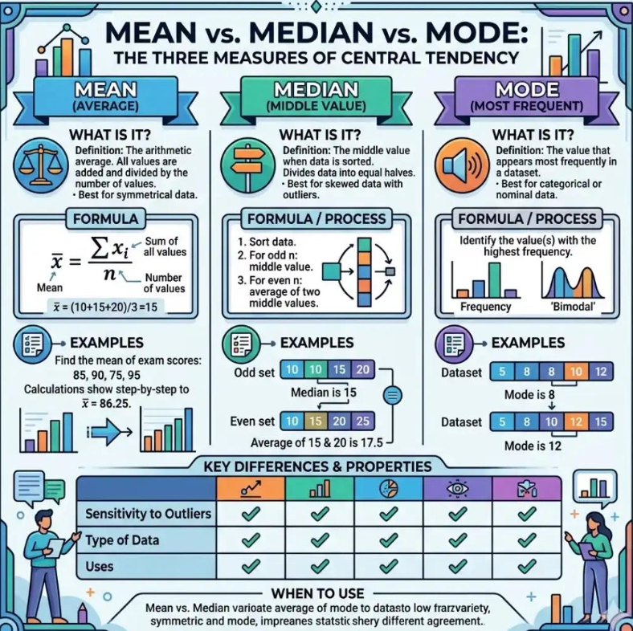
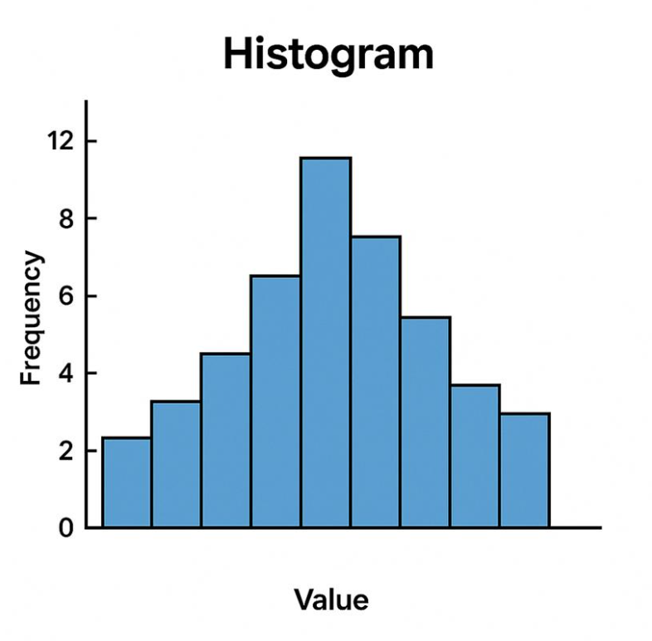
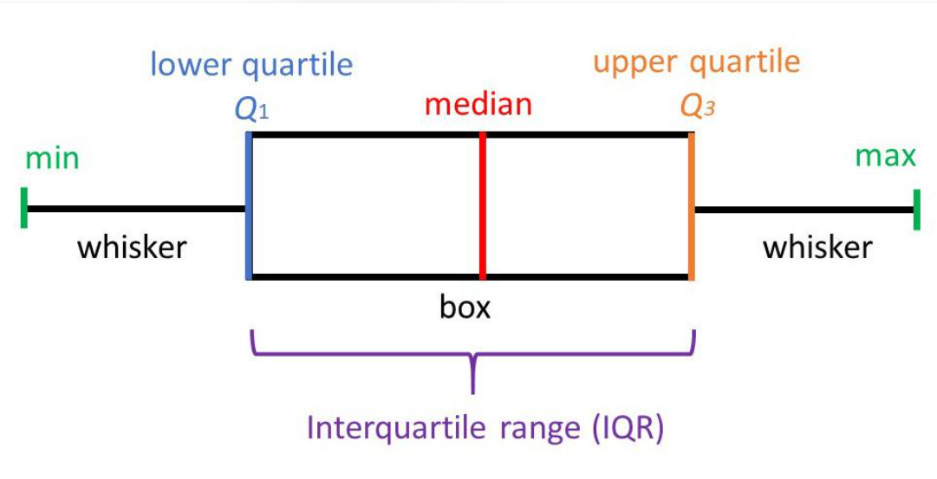

Study in this exact order:
- Frequency.
- Frequency Distribution.
- Relative Frequency.
- Cumulative Frequency.
- Mean.
- Median.
- Mode.
- Weighted Mean.
- Geometric Mean.
- Harmonic Mean.
- Range.
- Variance.
- Standard Deviation.
- Quartiles.
- Deciles.
- Percentiles.
- Interquartile Range.
- Five-Number Summary.
- Skewness.
- Kurtosis.
Advanced topics:
- Robust measures of central tendency.
- Robust measures of dispersion.
- Median Absolute Deviation.
- Winsorization.
- Trimmed Mean.
- Outlier detection.
- Standardization.
- Normalization.
Module 4. Data Distribution and Visualization Statistics
- Frequency Distribution.
- Normal Distribution.
- Uniform Distribution.
- Skewed Distribution.
- Left-skewed Distribution.
- Right-skewed Distribution.
- Multimodal Distribution.
- Bimodal Distribution.
- Bell Curve.
- Probability Density Function.
- Probability Mass Function.
- Cumulative Distribution Function.
- Empirical Distribution.
- Quantile Distribution.
- Distribution Comparison.
Visualization concepts:
- Histogram.
- Box Plot.
- Violin Plot.
- Density Plot.
- Q-Q Plot.
- ECDF Plot.
- Scatter Plot.
- Heatmap.

Module 5. Probability Theory
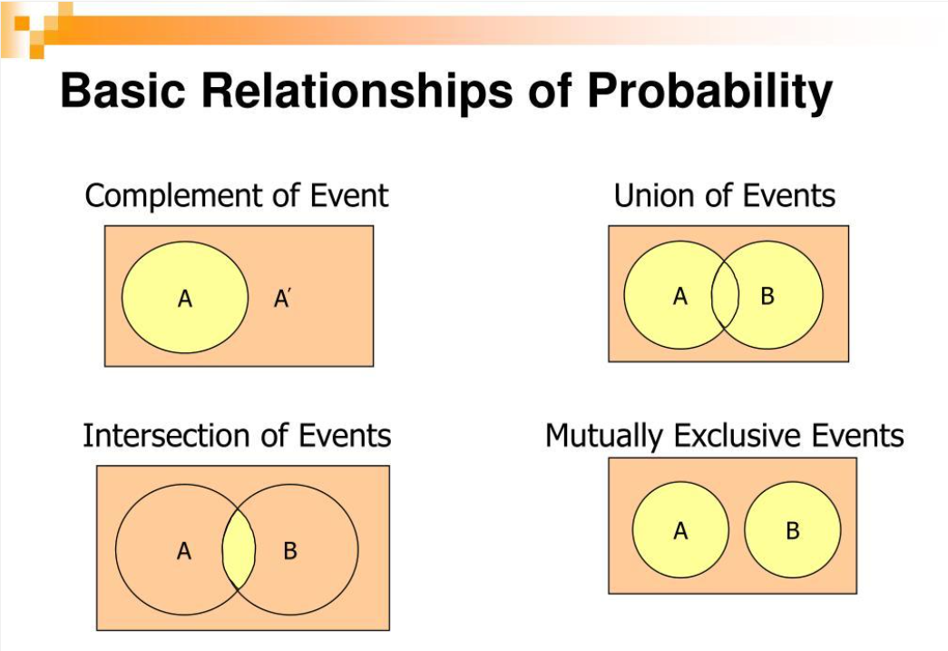
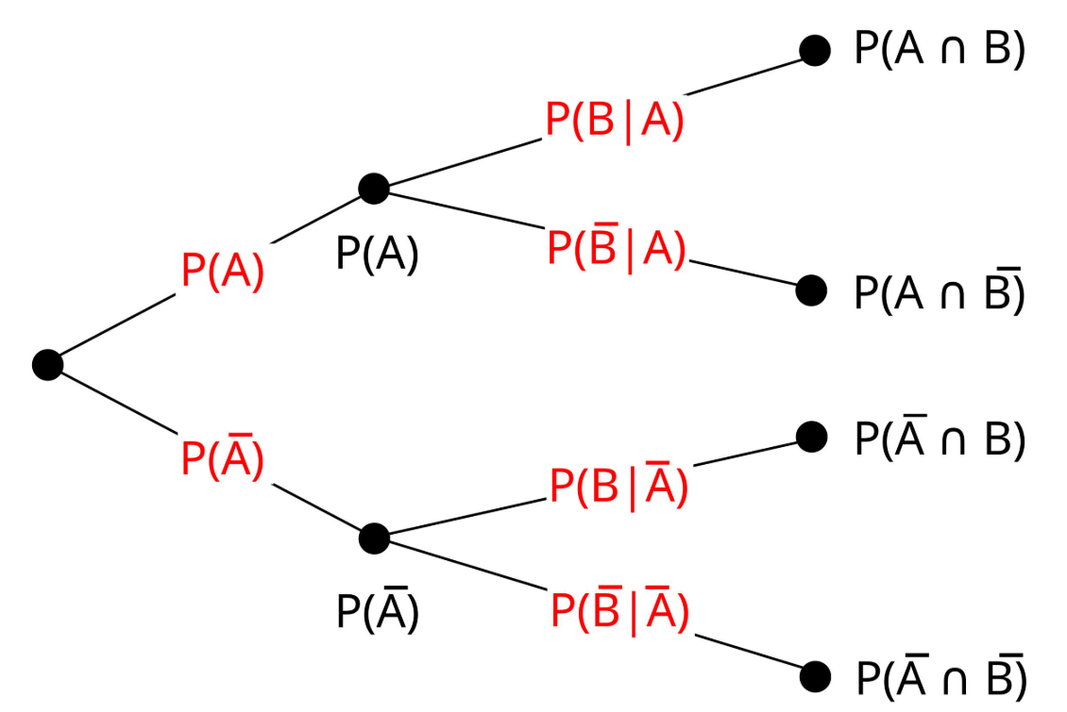
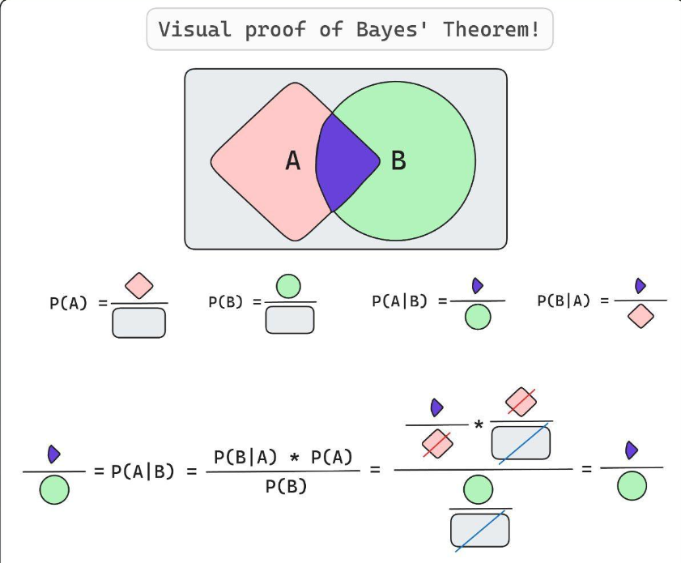

- Introduction to Probability.
- Random Experiments.
- Sample Space.
- Events.
- Simple Probability.
- Complementary Probability.
- Addition Rule.
- Multiplication Rule.
- Independent Events.
- Dependent Events.
- Mutually Exclusive Events.
- Conditional Probability.
- Joint Probability.
- Marginal Probability.
- Bayes' Theorem.
- Law of Total Probability.
- Random Variables.
- Discrete Random Variables.
- Continuous Random Variables.
- Expected Value.
- Variance of Random Variables.
Advanced:
- Conditional Independence.
- Law of Large Numbers.
- Central Limit Theorem.
- Monte Carlo Simulation.
- Markov Chains.
Module 6. Probability Distributions
Study every distribution individually.
Order | Distribution
1 | Bernoulli Distribution
2 | Binomial Distribution
3 | Geometric Distribution
4 | Negative Binomial Distribution
5 | Poisson Distribution
6 | Uniform Distribution
7 | Normal Distribution
8 | Standard Normal Distribution
9 | Exponential Distribution
10 | Gamma Distribution
11 | Beta Distribution
12 | Chi-Square Distribution
13 | Student's t-Distribution
14 | F-Distribution
15 | Weibull Distribution
16 | Log-Normal Distribution
For every distribution, understand:
- What it means.
- When to use it.
- Its assumptions.
- Its characteristics.
- Real-world applications.
- Python implementation.
Module 7. Sampling Techniques
- Population vs Sample.
- Sampling Frame.
- Simple Random Sampling.
- Systematic Sampling.
- Stratified Sampling.
- Cluster Sampling.
- Multistage Sampling.
- Convenience Sampling.
- Quota Sampling.
- Snowball Sampling.
- Sampling Bias.
- Selection Bias.
- Non-response Bias.
- Sampling Error.
- Sampling Distribution.
- Standard Error.
- Sample Size Determination.
- Bootstrap Sampling.
- Jackknife Resampling.

Module 8. Inferential Statistics
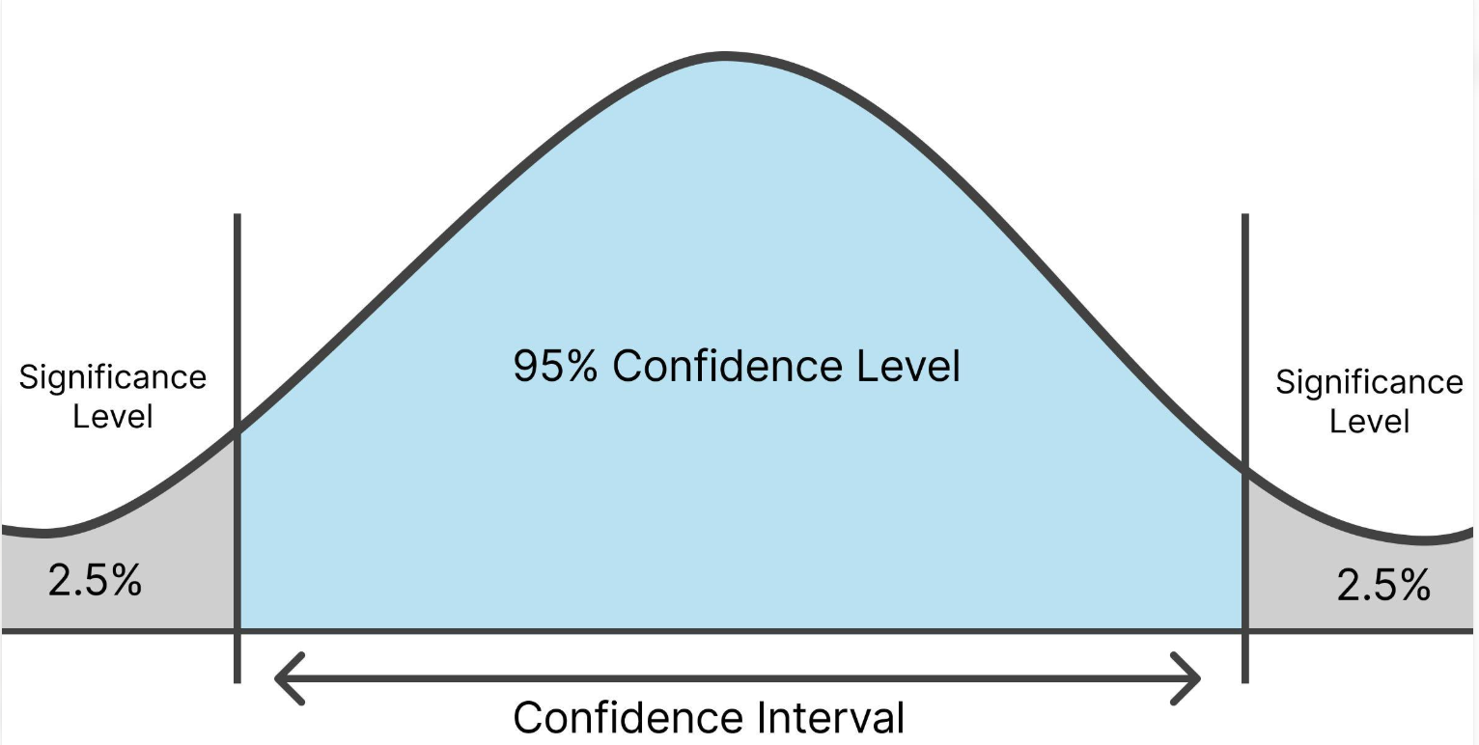
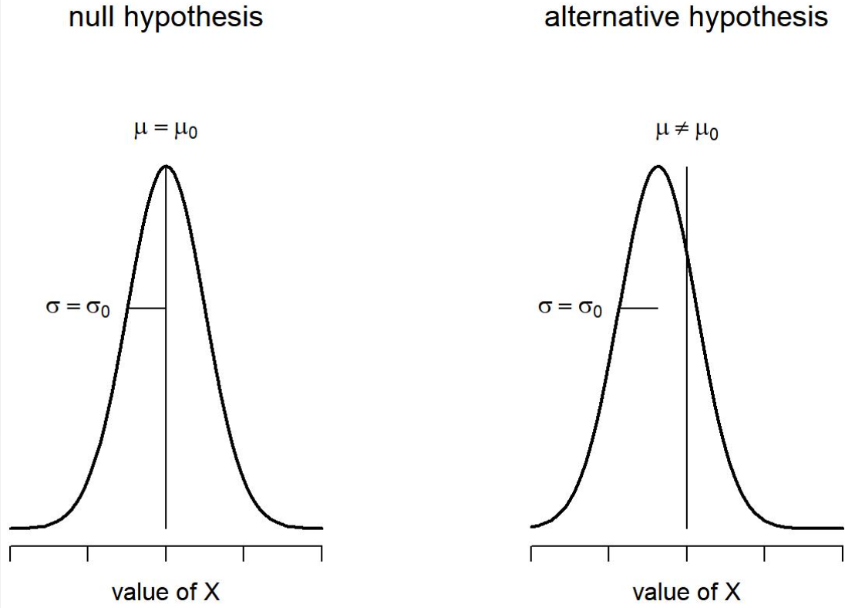
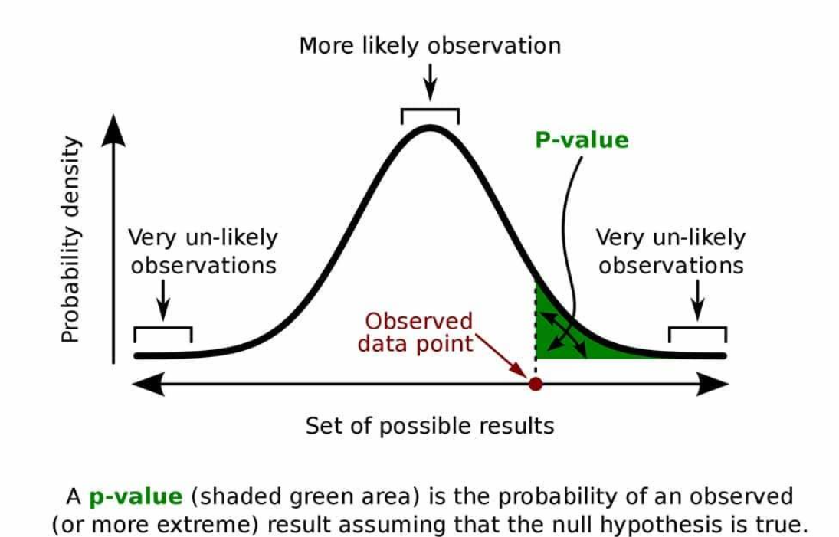
- Introduction to Inferential Statistics.
- Point Estimation.
- Interval Estimation.
- Confidence Intervals.
- Confidence Level.
- Margin of Error.
- Standard Error.
- Null Hypothesis.
- Alternative Hypothesis.
- Significance Level.
- P-value.
- Type I Error.
- Type II Error.
- Statistical Power.
- Effect Size.
- One-tailed Testing.
- Two-tailed Testing.
- Statistical Significance.
- Practical Significance.
- Multiple Hypothesis Testing.
Module 9. Hypothesis Testing
Master these tests in the following order.
Order | Statistical test | Application
1 | One-sample Z-test | Single population mean/proportion under suitable assumptions
2 | Two-sample Z-test | Comparing means/proportions
3 | One-sample t-test | One sample mean
4 | Independent t-test | Two independent groups
5 | Paired t-test | Before-and-after comparisons
6 | One-way ANOVA | Multiple group means
7 | Two-way ANOVA | Two categorical factors
8 | Chi-square Goodness of Fit | Categorical distribution
9 | Chi-square Independence | Categorical association
10 | Fisher's Exact Test | Small-sample categorical data
11 | Mann-Whitney U | Independent groups
12 | Wilcoxon Signed-Rank | Paired observations
13 | Kruskal-Wallis | Multiple independent groups
14 | McNemar's Test | Paired categorical outcomes
Advanced:
- Bonferroni Correction.
- Holm-Bonferroni.
- Benjamini-Hochberg.
- Permutation Testing.
- Bootstrap Testing.
- Sequential Hypothesis Testing.
Module 10. Correlation and Covariance
- Covariance.
- Positive Covariance.
- Negative Covariance.
- Pearson Correlation.
- Spearman Correlation.
- Kendall Correlation.
- Partial Correlation.
- Multiple Correlation.
- Correlation Matrix.
- Correlation Heatmap.
- Multicollinearity.
- Correlation vs Causation.
- Simpson's Paradox.
- Confounding Variables.
Module 11. Regression Statistics
- Simple Linear Regression.
- Multiple Linear Regression.
- Polynomial Regression.
- Logistic Regression.
- Ridge Regression.
- Lasso Regression.
- Elastic Net Regression.
- Quantile Regression.
- Poisson Regression.
- Negative Binomial Regression.
Regression diagnostics:
- R-squared.
- Adjusted R-squared.
- MAE.
- MSE.
- RMSE.
- Residual Analysis.
- Heteroscedasticity.
- Homoscedasticity.
- Multicollinearity.
- VIF.
- Autocorrelation.
- Regression Assumptions.
- Overfitting and Underfitting.
Module 12. Bayesian Statistics
- Introduction to Bayesian Statistics.
- Frequentist vs Bayesian Statistics.
- Prior Probability.
- Likelihood.
- Posterior Probability.
- Bayes' Theorem.
- Conjugate Priors.
- Bayesian Estimation.
- Bayesian Inference.
- Bayesian Hypothesis Testing.
- Bayesian A/B Testing.
- Credible Intervals.
- Bayesian Model Comparison.
- Markov Chain Monte Carlo.
- Gibbs Sampling.
- Metropolis-Hastings.
- Hierarchical Bayesian Models.
Module 13. Experimental Design and A/B Testing
- Experimental Design.
- Observational vs Experimental Studies.
- Randomization.
- Control Groups.
- Treatment Groups.
- Randomized Controlled Trials.
- Factorial Design.
- Blocking.
- Confounding.
- Sample Size Calculation.
- Statistical Power.
- A/B Testing.
- A/B/C Testing.
- Multivariate Testing.
- Conversion Rate Testing.
- Sequential Testing.
- Multiple Testing Problems.
- Experimentation Platforms.
- A/B Test Interpretation.
- Experimentation Pitfalls.
Module 14. Causal Inference
- Correlation vs Causation.
- Causal Relationships.
- Confounding.
- Directed Acyclic Graphs (DAGs).
- Treatment Effects.
- Average Treatment Effect.
- Average Treatment Effect on Treated.
- Potential Outcomes Framework.
- Propensity Score Matching.
- Inverse Probability Weighting.
- Difference-in-Differences.
- Regression Discontinuity.
- Instrumental Variables.
- Synthetic Control.
- Causal Forests.
- Double Machine Learning.
Module 15. Specialized and Advanced Statistics
Area | Topics
Time Series Statistics | Trend, seasonality, stationarity, autocorrelation
Survival Analysis | Kaplan-Meier, hazard functions, Cox regression
Multivariate Statistics | PCA, factor analysis, MANOVA
Nonparametric Statistics | Rank tests and distribution-free inference
Robust Statistics | Robust estimation and outlier-resistant methods
Spatial Statistics | Spatial autocorrelation and spatial modelling
Missing Data Statistics | MCAR, MAR, MNAR, imputation
Reliability Statistics | Failure rates, reliability and hazard modelling
Quality Control Statistics | Control charts, process capability, Six Sigma
Statistical Learning | Bias-variance trade-off, model selection, regularization
Statistics curriculum complete
Important distinction: This is a comprehensive curriculum, not a requirement to master every specialized statistical technique before touching Data Engineering or Data Science. The first 11 modules establish your core foundation. Modules 12–15 can be studied in parallel with the relevant advanced disciplines.
PHASE 2 — Advanced SQL and Database Engineering
After establishing your statistics foundation, take SQL and databases to an expert level.
Order | Topics
1 | Advanced SQL
2 | Advanced Joins
3 | Window Functions
4 | Recursive CTEs
5 | Query Execution Plans
6 | Query Optimization
7 | Database Indexing
8 | B-Tree and Hash Indexes
9 | Database Partitioning
10 | Database Sharding
11 | ACID Properties
12 | Transactions and Isolation Levels
13 | Locking and Deadlocks
14 | MVCC
15 | Database Normalization
16 | Database Denormalization
17 | OLTP vs OLAP
18 | Star Schema
19 | Snowflake Schema
20 | Data Vault Modelling
21 | Slowly Changing Dimensions
22 | Database Replication
23 | Materialized Views
24 | Database Internals
25 | Database Performance Tuning
Technologies: PostgreSQL, MySQL, SQL Server, Snowflake, BigQuery, Redshift.
PHASE 3 — Advanced Python
- Python internals.
- Data structures.
- Lists, tuples, sets and dictionaries.
- Iterators and generators.
- Decorators.
- Context managers.
- Object-oriented programming.
- Inheritance and polymorphism.
- SOLID principles.
- Design patterns.
- Exception handling.
- Logging.
- Type hints.
- Functional programming.
- Async programming.
- Multithreading.
- Multiprocessing.
- Memory management.
- Performance optimization.
- Profiling.
- Unit testing.
- Integration testing.
- Pytest.
- API development.
- Packaging and deployment.
Continue using Python for statistical programming, machine learning and pipeline development.
PHASE 4 — Advanced Data Analytics
This track focuses on extracting insights, making business decisions and solving complex analytical problems.
Order | Topics
1 | Advanced Exploratory Data Analysis
2 | Advanced Excel
3 | Advanced SQL Analytics
4 | Advanced Power BI
5 | DAX
6 | Data Modelling
7 | KPI Architecture
8 | Business Metrics
9 | Business Intelligence
10 | Product Analytics
11 | Customer Analytics
12 | Marketing Analytics
13 | Financial Analytics
14 | Supply Chain Analytics
15 | Inventory Analytics
16 | Cohort Analysis
17 | Funnel Analysis
18 | Retention Analysis
19 | Churn Analysis
20 | Customer Lifetime Value
21 | RFM Analysis
22 | Marketing Attribution
23 | Forecasting
24 | Root Cause Analysis
25 | Decision Science
26 | Causal Analytics
27 | Experimentation
28 | Analytics Storytelling
Advanced business applications:
- Revenue decomposition.
- Profitability analysis.
- Customer segmentation.
- Price elasticity.
- Demand forecasting.
- Inventory optimization.
- Customer lifetime value prediction.
- Marketing incrementality.
- Operational efficiency.
- Executive decision-making.
PHASE 5 — Advanced Data Science
Study in this sequence.
A. Machine Learning Foundations
- Introduction to Machine Learning.
- Supervised Learning.
- Unsupervised Learning.
- Semi-supervised Learning.
- Self-supervised Learning.
- Classification.
- Regression.
- Clustering.
- Feature Engineering.
- Feature Selection.
- Feature Scaling.
- Encoding.
- Train-Test Split.
- Cross-validation.
- Model Evaluation.
- Hyperparameter Tuning.
- Bias-Variance Trade-off.
- Overfitting and Underfitting.
- Regularization.
- Model Interpretability.
B. Machine Learning Algorithms
Regression
- Linear Regression.
- Ridge.
- Lasso.
- Elastic Net.
- Decision Tree Regression.
- Random Forest Regression.
- Gradient Boosting.
- XGBoost.
- LightGBM.
- CatBoost.
Classification
- Logistic Regression.
- Decision Tree.
- Random Forest.
- Naive Bayes.
- KNN.
- SVM.
- Gradient Boosting.
- XGBoost.
- LightGBM.
- CatBoost.
Clustering
- K-Means.
- Hierarchical Clustering.
- DBSCAN.
- Gaussian Mixture Models.
- Mean Shift.
- Spectral Clustering.
Advanced Machine Learning
- Anomaly Detection.
- Recommendation Systems.
- Imbalanced Learning.
- Ensemble Learning.
- Graph Machine Learning.
- Explainable AI.
- Causal Machine Learning.
C. Time Series and Forecasting
- Time Series Fundamentals.
- Trend and Seasonality.
- Stationarity.
- ACF and PACF.
- AR.
- MA.
- ARMA.
- ARIMA.
- SARIMA.
- Exponential Smoothing.
- Holt-Winters.
- Prophet.
- VAR.
- LSTM Forecasting.
- Forecast Evaluation.
- Backtesting.
- Forecast Monitoring.
D. Deep Learning
- Neural Network Fundamentals.
- Perceptron.
- Feedforward Neural Networks.
- Activation Functions.
- Loss Functions.
- Backpropagation.
- Gradient Descent.
- Optimizers.
- Regularization.
- CNN.
- RNN.
- LSTM.
- GRU.
- Attention Mechanism.
- Transformers.
- Autoencoders.
- GANs.
- Self-supervised Learning.
E. Specialized Data Science
- NLP.
- Computer Vision.
- Recommendation Engines.
- Fraud Detection.
- Anomaly Detection.
- Graph Analytics.
- Reinforcement Learning.
- Explainable AI.
- Generative AI.

PHASE 6 — Advanced Data Engineering
This is the discipline where I recommend spending substantial time developing hands-on engineering depth.
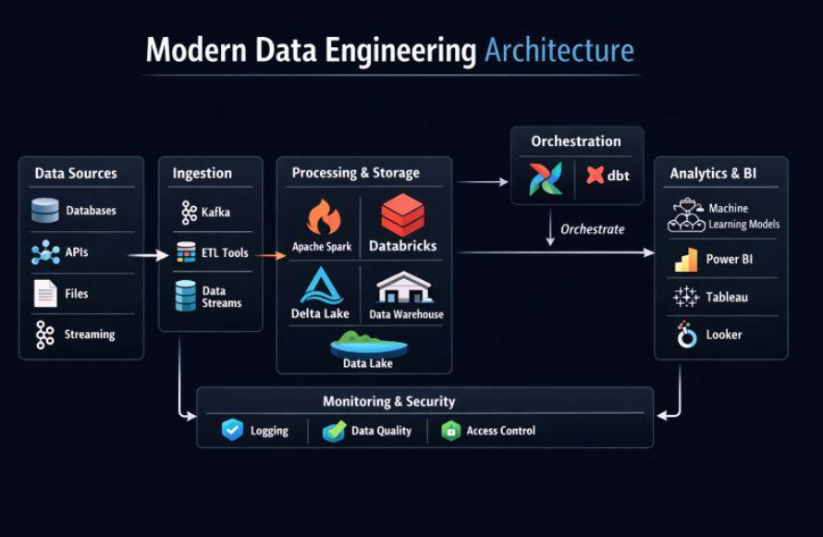

A. Data Engineering Fundamentals
- Data Engineering Architecture.
- Data Lifecycle.
- Data Ingestion.
- Data Extraction.
- ETL.
- ELT.
- Batch Processing.
- Stream Processing.
- Real-time Processing.
- Incremental Loading.
- Full Loading.
- CDC.
- Idempotency.
- Data Validation.
- Data Quality.
- Schema Evolution.
- Data Contracts.
- Data Lineage.
- Data Observability.
- Pipeline Monitoring.
B. Data Pipeline Engineering
- Pipeline architecture.
- Workflow orchestration.
- Dependency management.
- Scheduling.
- Retry mechanisms.
- Error handling.
- Backfilling.
- Checkpointing.
- Dead-letter queues.
- Exactly-once processing semantics.
- At-least-once delivery.
- At-most-once delivery.
- Pipeline recovery.
- Data reconciliation.
- Pipeline optimization.
C. Big Data Technologies
Technology | Topics
Hadoop | HDFS, YARN, architecture
Spark | RDD, DataFrames, Spark SQL
PySpark | Distributed processing
Kafka | Brokers, topics, partitions, consumers
Flink | Stateful stream processing
Hive | HiveQL, warehouse architecture
Airflow | DAGs, scheduling, orchestration
dbt | Transformations, testing, documentation
Iceberg | Open table formats
Delta Lake | Transactions and lakehouse
D. Data Warehousing
- Data Warehouse Architecture.
- Data Lake.
- Data Lakehouse.
- Data Marts.
- OLAP.
- OLTP.
- Dimensional Modelling.
- Star Schema.
- Snowflake Schema.
- Fact Tables.
- Dimension Tables.
- SCD Types.
- Data Vault.
- Partitioning.
- Clustering.
- Columnar Storage.
- Parquet.
- ORC.
- Metadata Management.
- Query Optimization.
E. Cloud Data Engineering
Start with AWS or GCP, then expand to another cloud.
- Amazon S3.
- AWS Glue.
- Amazon Redshift.
- Amazon EMR.
- Amazon Kinesis.
- Google Cloud Storage.
- BigQuery.
- Dataflow.
- Pub/Sub.
- Dataproc.
- Azure Data Factory.
- Azure Synapse.
- Azure Data Lake Storage.
F. Production Engineering
- Docker.
- Kubernetes.
- Git.
- GitHub Actions.
- CI/CD.
- Terraform.
- Infrastructure as Code.
- Monitoring.
- Logging.
- Alerting.
- Security.
- Data Governance.
- Cost Optimization.
- Disaster Recovery.
- High Availability.
- Performance Engineering.
PHASE 7 — System Design and Distributed Systems
This is important for advanced Data Engineering interviews.
Study:
- Client-Server Architecture.
- REST APIs.
- Networking Fundamentals.
- Load Balancing.
- Caching.
- Message Queues.
- Event-Driven Architecture.
- Distributed Databases.
- Replication.
- Sharding.
- Partitioning.
- CAP Theorem.
- Consistency Models.
- Distributed Transactions.
- Consensus.
- Fault Tolerance.
- Horizontal Scaling.
- Vertical Scaling.
- Microservices.
- Distributed Computing.
- High Availability.
- Disaster Recovery.
- Rate Limiting.
- Backpressure.
- System Observability.
Then separately master:
- High-Level Design.
- Low-Level Design.
- Database Design.
- API Design.
- Data Pipeline Design.
- Data Warehouse Design.
- Distributed System Design.
Practice designing YouTube, Netflix, Amazon, Uber, Instagram, large-scale ETL systems and real-time analytics platforms.
PHASE 8 — Generative AI and MLOps
- NLP Fundamentals.
- Transformer Architecture.
- LLM Fundamentals.
- Tokenization.
- Embeddings.
- Vector Databases.
- Semantic Search.
- RAG.
- Advanced RAG.
- Fine-tuning.
- Prompt Engineering.
- LLM Evaluation.
- AI Agents.
- Tool Calling.
- Multi-agent Systems.
- Model Deployment.
- Model Serving.
- MLOps.
- LLMOps.
- Model Monitoring.
- AI Governance.
- AI Security.
Tools: PyTorch, Hugging Face, MLflow, FastAPI, Ollama, LangChain, LlamaIndex, FAISS, Chroma and pgvector.
Your master learning order and approximate duration
This is how I would organize your complete journey.
Phase | Subject | Duration
1 | Statistics | 2–3 months
2 | Advanced SQL & Databases | 1 month
3 | Advanced Python | 1 month
4 | Advanced Data Analytics | 1 month
5 | Advanced Data Science | 2 months
6 | Advanced Data Engineering | 2–3 months
7 | System Design & Distributed Systems | 1–2 months
8 | Generative AI & MLOps | 1 month
9 | Integrated Projects & Interviews | 1–2 months
These durations are suggested study blocks, not guaranteed mastery periods. Some subjects should overlap, particularly SQL, Python, statistics and projects.
How to study Statistics: Your first 60 days
I would make Statistics your first dedicated learning track.
Statistics — 8-week learning tracker
Overall progress
0%
Week 1: Introduction and data classification
Introduction, population, sample, parameters, statistics, data types and measurement scales.
Week 2: Descriptive Statistics
Mean, median, mode, variance, standard deviation, quartiles and percentiles.
Week 3: Distribution and relationships
Skewness, kurtosis, outliers, covariance, correlation and visualization.
Week 4: Probability Theory
Probability rules, conditional probability, independence, Bayes' theorem and random variables.
Week 5: Probability Distributions
Bernoulli, Binomial, Poisson, Normal, Uniform, Exponential, t, Chi-square and F.
Week 6: Sampling and Inference
Sampling techniques, CLT, standard error, confidence intervals and estimation.
Week 7: Hypothesis Testing
Z-tests, t-tests, ANOVA, Chi-square, nonparametric tests, p-values and power.
Week 8: Regression and revision
Linear and logistic regression, regression diagnostics, practical exercises and assessment.
How I want you to master each topic
For example, when studying Standard Deviation, don't just memorize the formula.
Follow this structure:
Step | What you must do
1 | Understand the concept
2 | Understand its purpose
3 | Learn its formula
4 | Solve numerical examples manually
5 | Implement using Python
6 | Apply to a real dataset
7 | Interpret the results
8 | Solve interview questions
9 | Build a small practical project
10 | Explain the concept independently
For Statistics, use:
- Python.
- NumPy.
- Pandas.
- SciPy.
- Statsmodels.
- Matplotlib.
- Seaborn.
For Data Engineering, use:
- PostgreSQL.
- Python.
- Apache Spark.
- Kafka.
- Airflow.
- dbt.
- Docker.
- Cloud platforms.
For Data Science, use:
- Scikit-learn.
- XGBoost.
- PyTorch.
- Hugging Face.
- MLflow.
For Analytics, use:
- SQL.
- Excel.
- Power BI.
- Tableau.
- Python.
My final advice: Three important priorities
Priority 1: Become exceptionally strong in Statistics.
This will give you a strong foundation for advanced Data Science and Analytics. It will also help with data quality, reliability metrics, monitoring and operational analysis in Data Engineering.
Priority 2: Give Data Engineering additional attention.
Since you already have foundational exposure to Data Analytics and Data Science, use this opportunity to develop deeper engineering capabilities: databases, distributed computing, pipeline architecture, orchestration and system design.
Priority 3: Build integrated projects.
Eventually, build systems where all three disciplines work together:
Example: Enterprise Retail Intelligence Platform
Data Engineering
Ingestion → Kafka → Spark → Airflow → Data Warehouse
Data Analytics
SQL → KPIs → Customer Analytics → Business Intelligence
Data Science
Statistical Analysis → Forecasting → ML → Recommendations
Business Outcomes
Revenue Optimization · Demand Forecasting · Customer Retention

